**Solution 1:**

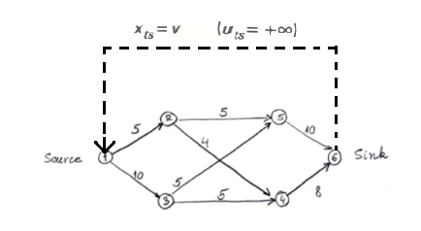

The virtual arc has been shown with bold dotted lines.

*xts* represents variable z, since *xts* simply returns the z unit of flow back to source from sink.

Maximize *xts* subject to,

$$\sum_{j}{x_{ij}}-\sum_{k}{x_{ji}}= 0 (i=1,2,3....,n)$$

$0≤x_{ij}≤u_{ij}$ (i=1,2,…n ; j= 1,2,…n)

**Solution 2:**

1. The 1200 mcf gas, Maximum usage and Tariff are used to calculate the Minimum Total cost of transportation, which is our decision variable.

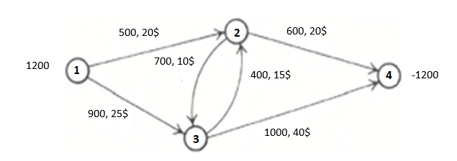

Minimize, $\sum_{ij}{c_{ij}f_{ij}}$

Subject to,

$f_{ij}≤U_{ij}$ $∀\left(i,j\right)∈E$

$\sum_{j}{f_{ij}}-\sum_{j}{f_{ji}}$ = b(i) $∀\left(j\right)∈V$

fij  0 $∀\left(i,j\right)∈E$

**Solution 3)** **Branch and Bound**

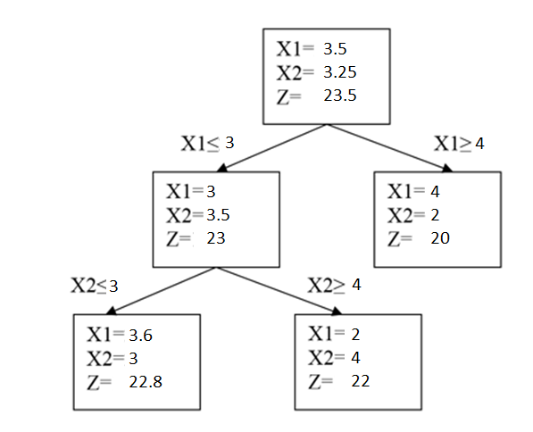

**Solution 4:**

$$\sum_{i=1}^{m}{o}\sum_{j=1}^{n}{c_{ij}x_{ij}}+\sum_{j=1}^{m}{f_{i}}y_{i}$$

Subject to,

$\sum_{j=1}^{m}{x_{ij}}$ = dj

i

Xij 0

Yi= 0 or 1 ( 0 means the warehouse is open and 1 means the warehouse is closed)

$Σ$